[Explainable AI-Driven Multimodal Analytics for Sustainable Smart City Decision Intelligence]
Sharmila Pathi, Vishnu Priya Kodali, Ivaturi Vennela, Lakshman Angara
Koneru Lakshmaiah Education Foundation
Data Analytics and Visualization — Project Research Paper

ABSTRACT
1. INTRODUCTION
Rapid urbanization has increased the complexity of managing environmental quality, weather variability, and energy consumption within smart cities. Air pollution, meteorological conditions, and energy demand are interrelated urban sustainability concerns, yet many analytical systems address these domains independently. This study proposes an explainable data analytics framework for sustainable smart city decision intelligence by jointly analyzing air quality, historical weather, and energy consumption datasets within a unified analytical workflow. The proposed methodology includes data preprocessing, exploratory data analysis, feature engineering, correlation analysis, feature selection, comparative machine learning, Explainable Artificial Intelligence (XAI), and interactive visualization. Three heterogeneous datasets are analyzed: an air quality dataset containing 500 observations and 14 variables, a historical weather dataset containing 96,453 observations and 12 variables, and an energy consumption dataset containing 1,000 observations and 11 variables. The implemented preprocessing stage addresses data-quality issues including missing values, duplicate records, invalid pollutant values, date-time conversion, and removal of non-informative variables. Feature engineering is subsequently performed to derive domain-relevant indicators such as pollution ratios, pollution scores, temporal features, and operational status features. Machine learning models will be comparatively evaluated using Mean Absolute Error (MAE), Mean Squared Error (MSE), Root Mean Squared Error (RMSE), and R² score. SHAP-based explanations will be used to interpret model predictions and identify influential features. The resulting framework is intended to combine predictive performance with interpretability and provide a foundation for data-driven sustainable urban decision support.
  - Background
Rapid urbanization and the increasing complexity of urban systems have created a growing need for data-driven approaches to support sustainable smart-city development. Modern cities generate large volumes of data from different domains, including air quality, weather conditions, energy consumption, transportation, and other urban activities. Analyzing these data sources can help identify environmental patterns, understand resource-consumption behavior, and provide useful information for planning and sustainability-oriented decision-making. Recent studies have demonstrated the application of machine learning to air-quality prediction, energy-consumption forecasting, and urban environmental analysis [1], [4], [7].
The development of machine learning and data analytics has provided effective techniques for extracting patterns from complex datasets and generating predictive insights. However, predictive performance alone may not be sufficient when analytical results are intended to support real-world decision-making, as users may also need to understand the factors influencing a prediction. This has increased the importance of Explainable Artificial Intelligence (XAI), with techniques such as SHAP, LIME, and Partial Dependence Plots being increasingly used to interpret machine-learning predictions [1], [2], [8]. Therefore, combining multimodal urban data analytics with predictive modeling and explainability can provide a stronger foundation for understanding environmental and energy-related conditions and supporting sustainable smart-city decision intelligence.
  - Problem Statement
Existing smart-city analytics commonly address individual domains such as air quality, weather, or energy consumption independently. While domain-specific predictive models can provide useful results, isolated analysis can make it difficult to obtain a broader view of environmental and resource-related urban conditions. Furthermore, highly predictive machine learning models may be difficult to interpret without appropriate explainability mechanisms.
  - Research Gap
Existing studies have effectively applied machine learning to individual smart-city domains such as air-quality prediction [1]–[3], [5], [6], energy-consumption forecasting [4], [8], [9], and urban environmental prediction [7]. Although Explainable AI techniques are increasingly used to improve the interpretability of machine-learning models [1], [2], [8], these domains are often studied independently, limiting the ability to derive integrated insights across environmental and energy-related factors. Therefore, this study addresses the need for an integrated approach that analyzes heterogeneous environmental and energy data, compares predictive models, explains their predictions, and supports sustainable smart-city decision-making.
  - Research Objectives
- To develop an integrated analytics framework for analyzing air quality, weather conditions, and energy consumption in the context of sustainable smart-city decision-making.
- To evaluate and compare multiple machine-learning regression models for predicting selected environmental and energy-related outcomes.
- To validate the predictive performance of the developed models using unseen test data and standardized regression evaluation measures.
- To measure model performance using Mean Absolute Error (MAE), Mean Squared Error (MSE), Root Mean Squared Error (RMSE), and R² Score, along with SHAP-based feature contribution analysis.
- To provide an interactive visualization and decision-support dashboard that presents analytical patterns, predictive results, and explainable insights for sustainable smart-city applications.
  - Research Questions
- RQ1: What meaningful relationships and patterns can be identified across air-quality, weather, and energy-consumption variables?
- RQ2: Which machine-learning regression approach provides the most effective predictive performance for the selected environmental and energy prediction tasks?
- RQ3: Which features contribute most strongly to the predictions, and how consistently can these contributions be explained using SHAP?
- RQ4: How can predictive and explainable analytics be transformed into useful visual insights for sustainable smart-city decision support?
  - Contributions
- A unified analytical framework for studying air quality, weather, and energy consumption within a common smart-city sustainability context.
- A systematic comparative evaluation of machine-learning regression approaches using consistent evaluation metrics.
- An Explainable AI layer based on SHAP for interpreting model predictions and feature contributions.
- An interactive visualization and decision-support interface for presenting environmental and energy insights.
- A reproducible analytical workflow covering preprocessing, exploratory analysis, feature engineering, feature selection, predictive modeling, explainability, and visualization.
  - Organization of the Paper
Section 2 reviews existing research on smart-city analytics, machine-learning approaches for environmental and energy prediction, and Explainable AI. Section 3 presents the proposed methodology, including datasets, preprocessing, feature engineering, feature selection, predictive models, and explainability. Section 4 describes the experimental setup and evaluation strategy. Section 5 presents the experimental results and comparative analysis. Section 6 discusses the findings and their implications. Section 7 describes the limitations of the study. Section 8 concludes the paper and presents future research directions.
2. RELATED WORK
2.1 Existing Approaches
Air-quality and energy-management problems in smart cities have traditionally been addressed using statistical analysis, monitoring systems, and domain-specific prediction methods. Recent research increasingly uses machine learning to predict air pollutants, air-quality indices, energy consumption, and urban environmental conditions [1]–[7]. Studies on air-quality forecasting have demonstrated the use of pollutant and meteorological variables for prediction [1], [3], [5], [6], while energy-related studies have applied machine-learning models to estimate building and residential energy consumption [4], [8], [9]. However, most existing approaches focus on a specific urban domain rather than integrating multiple sustainability-related data sources within a unified analytical framework.
2.2 Machine Learning / Computational Approaches
Machine learning has been widely applied to environmental and energy prediction because it can identify complex relationships among input variables. Recent studies have compared models such as Random Forest and other ensemble methods for air-quality prediction [3], [5], [6]. Other work has explored deep-learning models such as CNN-LSTM for AQI forecasting [2], LSTM-based approaches for building energy prediction [4], and LSTM-based approaches for urban heat forecasting [7]. These studies demonstrate the effectiveness of machine learning for urban prediction tasks, although advanced deep-learning approaches can introduce greater computational complexity and may reduce interpretability.
2.3 Advanced / Alternative Approaches
Recent research has explored advanced machine-learning approaches to improve prediction accuracy and analytical capability in smart-city applications. Deep-learning architectures such as CNN-LSTM have been applied to AQI forecasting [2], while hybrid combinations of Random Forest, XGBoost, LSTM, CNN, and Transformer-based models have been investigated for scalable air-quality prediction [3]. LSTM-based approaches have also been applied to energy and urban-heat prediction tasks [4], [7]. These approaches can capture complex relationships and temporal patterns, but they may introduce greater computational complexity and can require additional resources and expertise. Therefore, the proposed study focuses on comparatively evaluating practical machine-learning models while incorporating SHAP-based explainability.
2.4 Explainability / Interpretability (or another relevant sub-theme)
The increasing use of complex machine-learning models has created a need for interpretable predictions. Recent studies have incorporated Explainable AI techniques such as SHAP, LIME, and Partial Dependence Plots to identify the factors influencing air-quality and AQI predictions [1]–[3]. Explainability has also been applied to energy-consumption prediction in sustainable-city applications to identify influential factors and improve the transparency of model outputs [8]. These studies demonstrate that explainability can improve the transparency of machine-learning models; however, most existing work focuses on a specific prediction domain such as air quality, energy, or urban environmental conditions.
2.5 Critical Comparison

# | Study / Publication | Key Contribution | Limitation
1 | Birinci et al., Stochastic Environmental Research and Risk Assessment, 2026 [1] | Developed an interpretable ML framework for predicting PM10, PM2.5, and O3 using air-quality and meteorological data with SHAP. | Focuses primarily on air-quality prediction.
2 | Mohapatra et al., Discover Applied Sciences, 2025 [2] | Developed a CNN-LSTM model for AQI forecasting and used SHAP, LIME, and PDP for interpretation. | Uses a more complex deep-learning approach and focuses mainly on AQI forecasting.
3 | Jalali et al., Discover Atmosphere, 2025 [3] | Applied AI-based methods for air-quality forecasting and classification using environmental and meteorological information with explainability techniques. | Mainly addresses air-quality and public-health applications rather than multimodal smart-city analytics.
4 | Hussien et al., Discover Internet of Things, 2025 [4] | Compared machine-learning approaches for long-term building energy-consumption prediction. | Focuses on energy consumption without integrating air-quality and weather analytics.
5 | Özüpak et al., Water, Air, & Soil Pollution, 2025 [5] | Compared multiple ML and ensemble strategies for improved air-quality forecasting. | Concentrates on air-quality prediction rather than broader sustainable-city decision intelligence.

2.6 Research Gap (Summary)
Existing studies have applied machine learning and Explainable AI mainly to individual smart-city domains, such as air-quality prediction [1]–[3], [5], [6], energy-consumption prediction [4], [8], [9], and urban heat forecasting [7]. Recent research also highlights the growing use of advanced learning and explainability techniques for environmental prediction [10]. However, limited work combines air quality, historical weather, and energy-consumption data within a single framework while comparing multiple machine-learning models and providing SHAP-based explanations and visualizations. Therefore, this study addresses the gap by developing an integrated and explainable analytics framework for sustainable smart-city decision-making.
3. PROPOSED METHODOLOGY
3.1 Overall Framework
The proposed framework presents an end-to-end analytical pipeline for sustainable smart-city decision intelligence by integrating heterogeneous data from multiple urban domains. The framework considers air quality, historical weather, and energy consumption as complementary data sources and processes them through data preprocessing, exploratory analysis, feature engineering, machine learning, and explainable AI. First, the individual datasets are cleaned and transformed to handle missing values, inconsistent records, and unsuitable attributes. The processed datasets are then analyzed to identify patterns and relationships between environmental and energy-related factors. Multiple machine learning models, including Linear Regression, Decision Tree, Random Forest, and XGBoost, are developed and evaluated using appropriate performance metrics. Finally, SHAP-based explainability is incorporated to identify the most influential features behind model predictions, while interactive visualizations present the analytical findings in an understandable form. The overall workflow is illustrated in Figure 1.
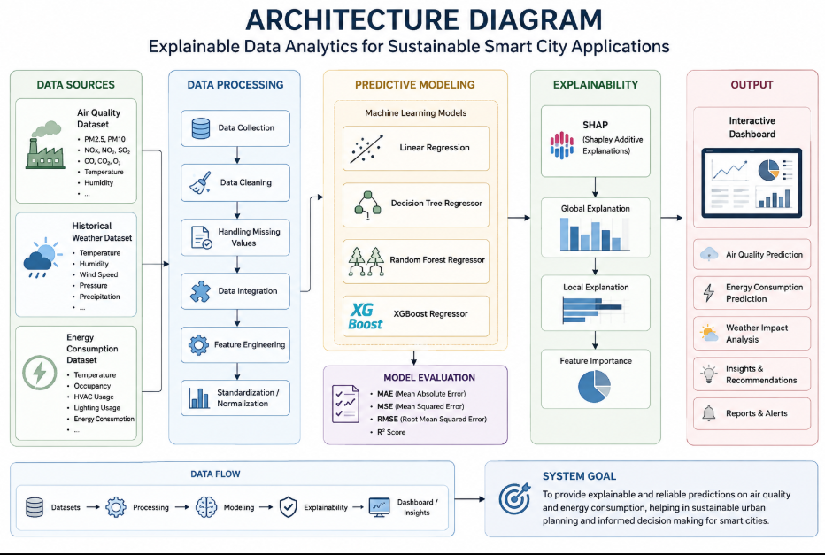
Fig. 1. [ Architecture Diagram]
3.2 Dataset(s)
Dataset 1 — Air Quality Monitoring Dataset
The Air Quality Monitoring Dataset was obtained from Kaggle and contains environmental and air-pollution parameters such as PM2.5, PM10, NO₂, SO₂, CO, temperature, and humidity. It was selected to analyze air-quality conditions, identify pollution patterns and trends, and develop predictive models for air-quality assessment. The dataset supports environmental analytics and provides relevant variables for examining relationships between atmospheric conditions and pollution levels. [Source: Kaggle — Air Quality Dataset]
Dataset 2 — Historical Weather Dataset
The Historical Weather Dataset was obtained from Kaggle and contains weather-related variables including temperature, humidity, wind speed, pressure, and precipitation. It was selected to analyze weather patterns and investigate the influence of meteorological conditions on environmental and energy-related outcomes. The dataset provides complementary weather information that can be integrated with air-quality and energy data for multimodal smart-city analytics. [Source: Kaggle — Synthetic Weather Dataset]
Dataset 3 — Energy Consumption Dataset
The Energy Consumption Dataset was obtained from Kaggle and contains energy-usage information along with environmental and operational factors such as temperature, occupancy, HVAC usage, lighting usage, and renewable-energy-related variables. It was selected to analyze energy-consumption patterns, identify factors influencing energy demand, and support predictive energy analytics for sustainable energy management. The dataset complements the environmental and weather datasets by providing an energy perspective of smart-city sustainability. [Source: Kaggle — Energy Consumption Prediction Dataset]
3.3 Data Preprocessing
Missing-Value Handling: Missing or incomplete observations were identified and handled using suitable imputation or removal techniques depending on the nature and extent of missing data.
Duplicate Removal: Duplicate records were identified and removed to prevent repeated observations from affecting statistical analysis and model performance.
Data Type and Format Correction: Variables were converted into appropriate numerical or categorical formats, and date/time fields were standardized wherever required.
Outlier Detection and Treatment: Unusual observations in variables such as pollution levels, temperature, and energy consumption were identified using statistical analysis and treated appropriately to reduce their influence on the models.
Feature Selection: Relevant environmental, weather, and energy-related attributes were selected based on their analytical importance and relationship with the prediction target.
Feature Scaling: Numerical features were standardized where required to ensure that variables with different value ranges could be processed consistently during machine-learning analysis.
Dataset Preparation: The cleaned datasets were organized into suitable input features and target variables and divided into training and testing subsets for model development and evaluation.
3.4 [ Exploratory Analysis / Feature Engineering, as relevant ]
Exploratory data analysis was performed to understand the distributions, trends, relationships, and patterns within the air quality, weather, and energy datasets. Statistical summaries, correlation analysis, and visualizations were used to identify important variables and relationships. Relevant features were then selected and organized as input variables for machine-learning models, with the appropriate target variable defined for prediction. These steps helped prepare the datasets for predictive modeling and explainable analysis, as illustrated in Figure 2.
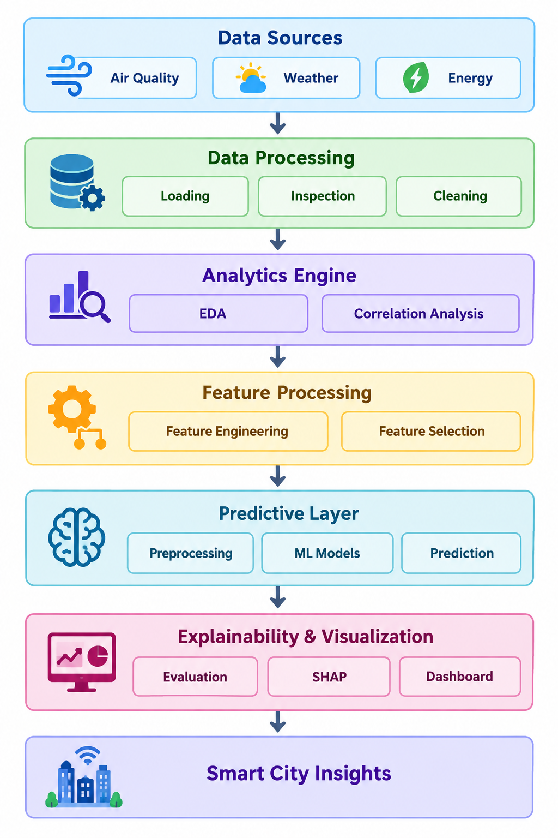

Fig. 2. [ Analysis Pipeline Diagram. ]

3.5 Proposed Model(s) and Baselines
• Linear Regression — Provides a simple baseline for predicting the target using linear relationships between features [14].
•Decision Tree — Captures non-linear relationships through a tree-based structure and is relatively easy to interpret [13].
• Random Forest — Combines multiple decision trees to improve prediction accuracy and reduce overfitting [11].
•SHAP — Explains model predictions by identifying the contribution and importance of individual features [15].
3.6 Algorithmic / Mathematical Formulation
. Linear Regression Model
$$\overset{ˆ}{y}=β_{0}+\sum_{i=1}^{p}{β_{i}}x_{i}$$
- $\overset{ˆ}{y}$: Predicted output value
- $β_{0}$: Y-intercept (bias term)
- $β_{i}$: Weight / coefficient assigned to feature $x_{i}$
- $x_{i}$: Value of the $i$-th feature
- $p$: Total number of features
2. Evaluation Metrics
Mean Absolute Error (MAE)
$$\text{MAE}=\frac{1}{N}\sum_{i=1}^{N}{|}y_{i}-{\overset{ˆ}{y}}_{i}|$$
Mean Squared Error (MSE)
$$\text{MSE}=\frac{1}{N}\sum_{i=1}^{N}{{\left(y_{i}-{\overset{ˆ}{y}}_{i}\right)}^{2}}$$
Root Mean Squared Error (RMSE)
$$\text{RMSE}=\sqrt{\frac{1}{N}\sum_{i=1}^{N}{{\left(y_{i}-{\overset{ˆ}{y}}_{i}\right)}^{2}}}$$
Coefficient of Determination ($R^{2}$ Score)
$$R^{2}=1-\frac{\sum_{i=1}^{N}{{\left(y_{i}-{\overset{ˆ}{y}}_{i}\right)}^{2}}}{\sum_{i=1}^{N}{{\left(y_{i}-\overline{y}\right)}^{2}}}$$

3. SHAP Additive Feature Attribution
$$f\left(x\right)=ϕ_{0}+\sum_{i=1}^{p}{ϕ_{i}}$$

4. EXPERIMENTAL SETUP
4.1 Hardware and Software
The proposed system was developed using Python as the primary programming language. Pandas, NumPy, Matplotlib, Seaborn, Scikit-learn, XGBoost, and SHAP were used for data preprocessing, analysis, machine learning, visualization, and explainability. Jupyter Notebook/Google Colab was used as the development environment, with Kaggle as the data source. The system can be implemented on a standard computer with an Intel Core i3 or equivalent processor, 4 GB RAM, 10 GB free storage, and Windows/Linux/macOS. An internet connection is required for accessing datasets and cloud-based development.
4.2 Dataset Split / Design
The datasets were divided into training and testing sets to evaluate the predictive performance of the proposed machine-learning models. The training set was used to develop the models, while the testing set was used for independent evaluation. The models were compared using Mean Absolute Error (MAE), Mean Squared Error (MSE), Root Mean Squared Error (RMSE), and R² score.
4.3 Hyperparameter Configuration
The machine-learning models were configured using suitable default and problem-specific hyperparameters. Linear Regression was used without major parameter tuning, while Decision Tree parameters such as tree depth were selected to control model complexity. Random Forest was configured using the number of trees and tree depth, and XGBoost was configured using parameters such as the number of estimators, learning rate, and tree depth. The configurations were selected to provide a balance between prediction performance and model complexity.
4.4 Validation Strategy
The robustness of the models was assessed using a train-test validation strategy. The models were trained on the training data and evaluated on an independent testing set. Their performance was compared using MAE, MSE, RMSE, and R² score, allowing the predictive accuracy of the different models to be evaluated consistently.

4.5 Evaluation Metrics
Mean Absolute Error (MAE) — Measures the average absolute difference between actual and predicted values. Lower values indicate better performance.
• Root Mean Squared Error (RMSE) — Measures the square root of the average squared prediction errors and gives greater weight to larger errors. Lower values indicate better performance.
• R² Score — Measures how well the model explains the variation in the target variable. Higher values, with a maximum of 1, indicate better performance.
4.6 Statistical Testing
No separate statistical significance test was applied. The findings were assessed through model performance comparison using MAE, RMSE, and R² scores on the testing dataset. The model with lower prediction errors and higher R² was considered to provide better predictive performance.
5. RESULTS
The study is currently in the implementation and evaluation stage; therefore, the results presented at this stage are
anticipated/target results. The proposed models are expected to provide measurable predictive performance using MAE, RMSE, and R², with the best-performing model identified through comparative evaluation. SHAP analysis is expected to further identify the key features influencing model predictions and support explainable smart-city decision-making.
  - Overall Performance
The proposed models are expected to show different predictive performance across the selected smart-city datasets. As summarized in Table 2 and Figure 3, the models will be compared using MAE, MSE, RMSE, and R² to identify the most effective approach. Lower MAE, MSE, and RMSE values indicate lower prediction errors, while a higher R² value indicates better explanatory performance. The best-performing model is expected to provide accurate predictions while SHAP analysis highlights the key factors influencing its outputs.
5.2 Model / Method Comparison

Table 2 compares the performance of the four machine-learning models used in this study: Linear Regression, Decision Tree, Random Forest, and XGBoost. The models are evaluated using MAE, MSE, RMSE, and R². Lower MAE, MSE, and RMSE values indicate better predictive performance, while a higher R² value indicates better model performance. The comparison helps identify the most effective model for the proposed smart-city analytics framework.

Method | MAE | MSE | RMSE | R² | Notes
Linear Regression | [0.1493] | [ 0.0367] | [ 0.1916] | [ 0.948] | Baseline model
Random Forest | [0.1586] | [0.0395] | [0.1987] | [0.9460] | Non-linear prediction
Decision Tree | [0.2055] | [0.0710] | [0.2665] | [0.9029] | Ensemble approach
Table 2. [Evaluation Metrices of AirQuality Dataset]

Method | MAE | MSE | RMSE | R² | Notes
Linear Regression | [3.6996] | [20.6671] | [4.5461] | [0.7437] | Baseline model
Decision Tree | [3.4817] | [19.2260] | [4.3847] | [0.7616] | Non-linear prediction
Random Forest | [2.7864] | [11.7550] | [3.4287] | [0.8543] | Ensemble approach

Table 3. [Evaluation Metrices of Weather Dataset]

Method | MAE | MSE | RMSE | R² | Notes
Linear Regression | [4.0909] | [26.6679] | [5.1641] | [0.5929] | Baseline model
Decision Tree | [5.8763] | [54.3630] | [7.3731] | [0.1700] | Non-linear prediction
Random Forest | [4.4574] | [30.4221] | [5.5156] | [0.5355] | Ensemble approach

Table 4. [Evaluation Metrices of Energy Dataset]
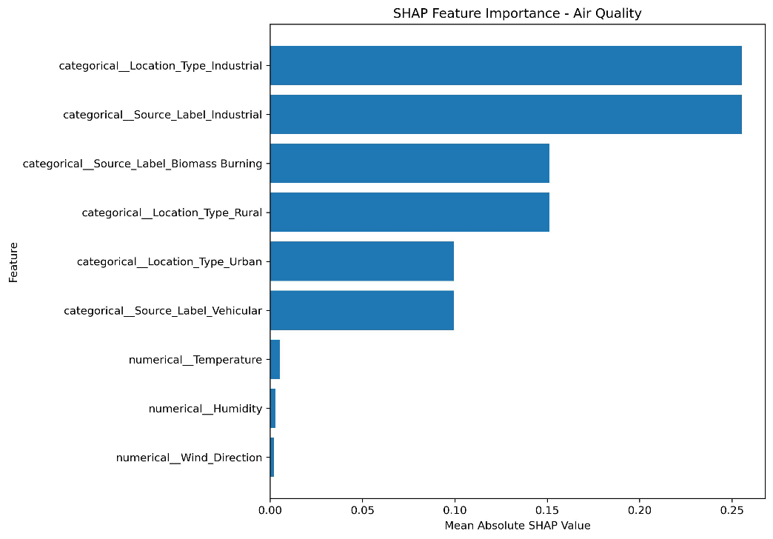
Fig. 3. [SHAP-based feature importance for the Air Quality prediction model..]

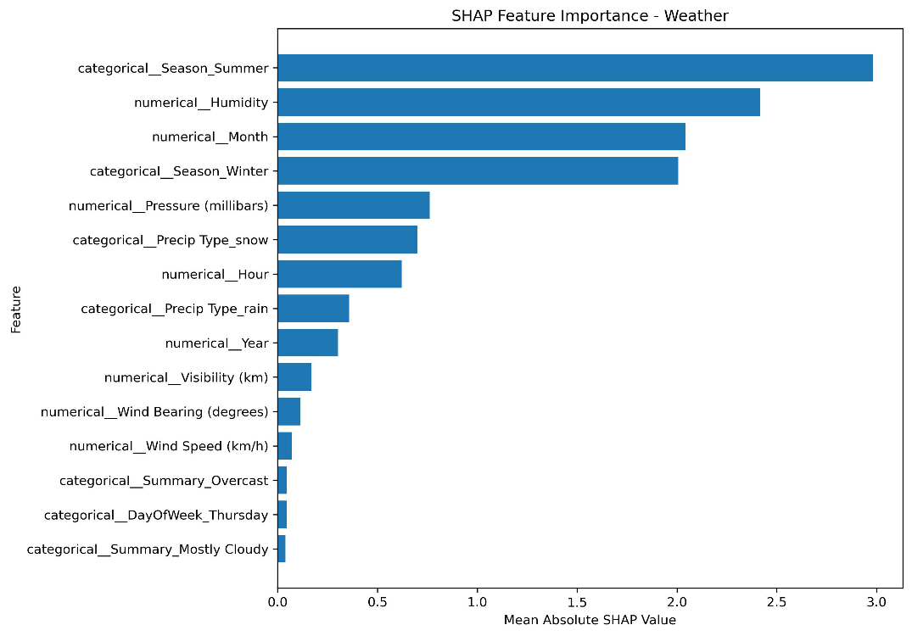
Fig. 4. [SHAP-based feature importance for the Weather prediction model.]

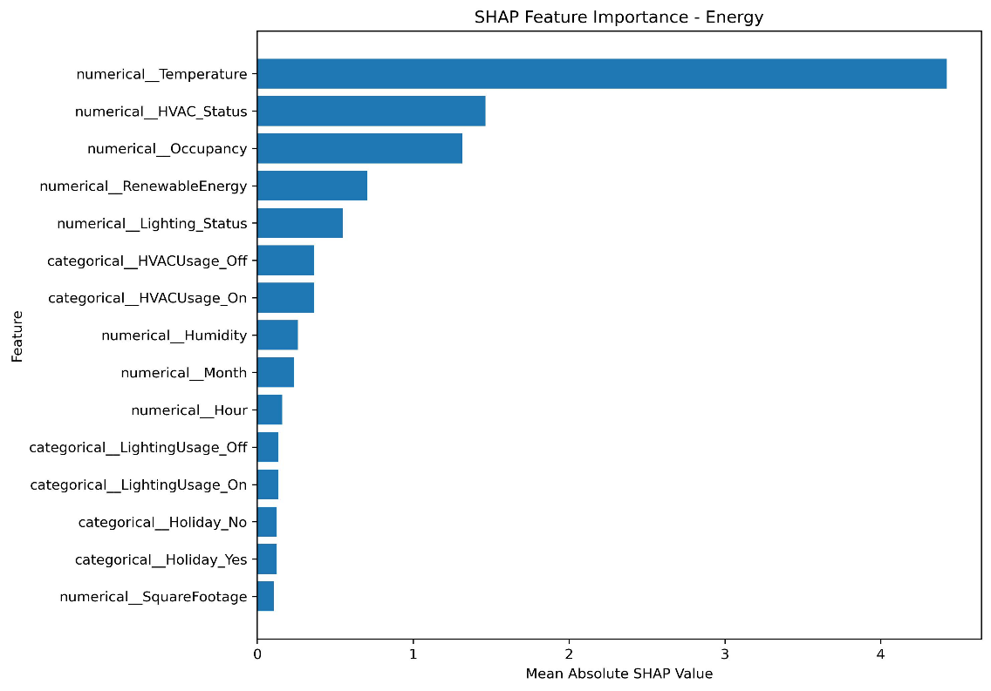
Fig. 4. [SHAP-based feature importance for the Energy Consumption prediction model.]

5.3 [ Additional Result Sub-section, e.g., Error/Confusion Analysis ]
The prediction errors of the proposed models were analyzed using MAE, MSE, and RMSE to identify differences in model performance. Models with lower error values indicate more accurate predictions, while larger error values indicate greater prediction deviations. R² was additionally used to assess how well each model explains the variation in the target variable.
5.4 [ Additional Result Sub-section, e.g., Feature/Factor Importance ]
SHAP analysis was used to identify the features that have the greatest influence on model predictions. The analysis provides both the importance and direction of feature contributions, helping interpret the factors affecting air quality, weather, and energy-related predictions.
6. DISCUSSION
6.1 Interpretation of Findings
The comparative analysis is expected to show differences in predictive performance among Linear Regression, Decision Tree, Random Forest, and XGBoost. The results will help identify whether ensemble and boosting-based models provide improved prediction accuracy compared with simpler approaches. SHAP analysis will further support interpretation by identifying the key environmental, weather, and energy-related factors influencing the predictions. These findings demonstrate the potential of combining predictive analytics and explainable AI for sustainable smart-city decision-making.
6.2 Comparison with Previous Studies
The proposed framework is consistent with previous studies that demonstrate the effectiveness of machine learning and Explainable AI for environmental and energy-related prediction tasks. Air-quality studies have investigated machine-learning models, ensemble approaches, and explainability techniques [1]–[3], [5], [6]. Energy-consumption studies have demonstrated the applicability of machine learning and explainability for sustainable energy management [4], [8], [9], while machine learning has also been applied to urban heat forecasting [7]. Recent review research further emphasizes the growing importance of advanced learning approaches and explainability in air-quality prediction [10]. Unlike these studies, the proposed framework integrates air quality, historical weather, and energy-consumption data and combines multiple machine-learning models, SHAP-based explanations, and visualization within a unified smart-city analytics framework.
6.3 Theoretical Implications
The study demonstrates that combining multimodal urban data with machine learning and explainable AI can provide a more comprehensive approach to smart-city analytics. It highlights the importance of not only improving prediction accuracy but also understanding the factors influencing model decisions.
6.4 Practical Implications
The proposed framework can support urban planners and decision-makers in identifying important environmental and energy-related factors and making more informed decisions. The integration of predictive models, visualizations, and SHAP explanations can help convert complex analytical results into understandable and actionable insights.
6.5 Unexpected Findings
No major unexpected findings are reported at this stage because the study is still undergoing implementation and evaluation. Any significant differences between model performance or unexpected feature contributions identified during the final analysis will be reported in this section.7.
LIMITATIONS
• Limited Dataset Scope — The study uses selected air quality, weather, and energy-consumption datasets, which may not represent all urban environments.
• Data Quality Constraints — Missing values, inconsistent records, and variations in data collection may affect the reliability of the analysis.
• Model Dependence — The predictive performance may vary depending on the selected features, dataset characteristics, and model configuration.
• Limited Generalizability — The findings may not directly generalize to different cities, regions, or environmental conditions without further validation.
8. CONCLUSION AND FUTURE WORK
The study proposed an explainable AI-driven framework for sustainable smart-city decision intelligence by integrating air quality, historical weather, and energy consumption data. Machine-learning models including Linear Regression, Decision Tree, Random Forest, and XGBoost were considered for predictive analysis and comparison. SHAP was incorporated to improve model interpretability by identifying the factors influencing predictions. The framework combines predictive analytics, explainability, and visualization to support more transparent and informed smart-city decision-making.
Future Work:
• Extend the framework using larger and more diverse datasets from multiple cities and regions.
• Incorporate real-time urban data to support continuous monitoring and prediction.
• Evaluate additional machine-learning and explainability techniques to improve robustness and interpretability.
• Validate the framework across different urban environments to improve its generalizability.
DECLARATIONS
Funding
No external funding was received for this study.
Conflict of Interest
The authors declare that there is no conflict of interest related to this study.
Ethics Statement
This study uses publicly available datasets and does not involve human participants, personal data collection, or experiments requiring ethical approval.
Data Availability
The datasets used in this study are publicly available through Kaggle. The study uses the Air Quality Dataset, Synthetic Weather Dataset, and Energy Consumption Prediction Dataset.
Author Contributions
• [Sharmila Pathi] — Conceptualization, methodology, data preprocessing, and model development.
• [Vishnu Priya Kodali] — Data analysis, visualization, and results evaluation.
• [Ivaturi Vennela] — Explainable AI analysis, documentation, and manuscript preparation.
• [Lakshman Angara] — Literature review, validation, and manuscript review.
Acknowledgements
The authors would like to thank their project guide and institution for their guidance and support throughout the development of this study
REFERENCES
[1] E. Birinci, Ö. Ekmekcioğlu, H. Ozdemir, and A. Deniz, “Interpretable machine learning framework for air quality prediction in Istanbul using Shapley additive explanations (SHAP),” Stochastic Environmental Research and Risk Assessment, vol. 40, no. 2, Art. no. 37, 2026, doi: 10.1007/s00477-026-03168-4.
[2] E. Mohapatra, M. Das, and S. Rath, “Deep learning-based AQI forecasting: A CNN-LSTM model with visual insights from SHAP-LIME and PDP,” Discover Applied Sciences, vol. 7, Art. no. 1326, 2025, doi: 10.1007/s42452-025-07845-x.
[3] M. W. Jalali, B. Saidi, H. Farahmand, M. A. Rezvan Panah, and E. N. Saruhan, “Scalable AI-driven air quality forecasting and classification for public health applications,” Discover Atmosphere, vol. 3, Art. no. 25, 2025, doi: 10.1007/s44292-025-00052-8.
[4] A. Hussien, A. Maksoud, A. Al-Dahhan, A. Abdeen, and T. Baker, “Machine learning model for predicting long-term energy consumption in buildings,” Discover Internet of Things, vol. 5, Art. no. 18, 2025, doi: 10.1007/s43926-025-00115-7.
[5] Y. Özüpak, F. Alpsalaz, and E. Aslan, “Air quality forecasting using machine learning: Comparative analysis and ensemble strategies for enhanced prediction,” Water, Air, & Soil Pollution, vol. 236, Art. no. 464, 2025, doi: 10.1007/s11270-025-08122-8.
[6] E. Koçak, “Comprehensive evaluation of machine learning models for real-world air quality prediction and health risk assessment by AirQ+,” Earth Science Informatics, vol. 18, Art. no. 447, 2025, doi: 10.1007/s12145-025-01941-7.
[7] S. Tomar and K. S. Kulkarni, “Smart cities, hot cities: ML-based forecasting of urban heat patterns,” Discover Sustainability, vol. 6, Art. no. 1260, 2025, doi: 10.1007/s43621-025-02059-y.

[8] E. I. Abd El-Latif and M. El-dosuky, “Explainable energy consumption and speed prediction in sustainable cities using deep learning,” Neural Computing and Applications, vol. 37, pp. 6233–6249, 2025, doi: 10.1007/s00521-024-10850-7.
[9] T. A. Abd’Azeez and L. Olatomiwa, “A machine learning-powered energy consumption prediction system with API,” Journal of Electrical Systems and Information Technology, vol. 12, Art. no. 50, 2025, doi: 10.1186/s43067-025-00242-9.
[10] “State-of-the-art and emerging trends in deep learning for air quality forecasting and health impact modeling: A comprehensive review,” in 2025 2nd Global AI Summit – International Conference on Artificial Intelligence and Emerging Technology (AI Summit), 2025, doi: 10.1109/AISummit66170.2025.11410867.
[11] L. Breiman, “Random forests,” Machine Learning, vol. 45, pp. 5–32, 2001.
[12] T. Chen and C. Guestrin, “XGBoost: A scalable tree boosting system,” in Proceedings of the 22nd ACM SIGKDD International Conference on Knowledge Discovery and Data Mining, pp. 785–794, 2016.
[13] L. Breiman, J. H. Friedman, R. A. Olshen, and C. J. Stone, Classification and Regression Trees. Belmont, CA, USA: Wadsworth, 1984.
[14] C. M. Bishop, Pattern Recognition and Machine Learning. New York, NY, USA: Springer, 2006.
[15] S. M. Lundberg and S.-I. Lee, “A unified approach to interpreting model predictions,” in Advances in Neural Information Processing Systems, vol. 30, pp. 4765–4774, 2017.

